Vanderbilt University Medical Center

Vanderbilt Vascular Access Rounds 2026S CME

Date: 05:00 August 29, 2026 - 08:00 August, 29, 2026

Accreditation

Vanderbilt University Medical Center is accredited by the Accreditation Council for Continuing Medical Education to provide continuing medical education for physicians.

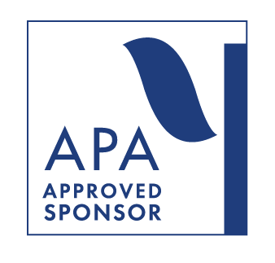

Credit Designation

Vanderbilt University Medical Center designates this live activity for a maximum of 2.50 AMA PRA Category 1 Credit(s)TM. Physicians should claim only the credit commensurate with the extent of their participation in the activity

Objectives
After participating in this educational activity, you should be able to:
1 Understand the value and aim of our Vascular Access Program
2 Properly coordinate and refer patients in need
3 Improve patient care by applying dedicated and targeted treatment strategies

Commercial Support
Vanderbilt University Medical Center Department of Vascular Surgery expresses appreciation to the following companies for their support of this educational activity by providing unrestricted educational grants: Venova Medical, Flex Vascular, Laminate Medical, Merit Medical, Mozarc Medical

Financial Disclosures
VUMC CE activities are compliant with the Standards for Integrity and Independence in accredited continuing education. Any individual in a position to control the content of a CE activity, including but not limited to planners and faculty, are required to disclose all relevant financial relationships with ineligible organizations.

All relevant conflicts of interest have been mitigated before this activity started.

Name of individual | Individual's role in activity | Nature of Relationship(s) / Name of Ineligible Company(s)
Evan Davis, MHA | CME/CE Associate | Nothing to disclose - 06/18/2026
Monique N Drago, EdD | CPD Team | Nothing to disclose - 08/05/2026
Renea M Furnald, BA | CME/CE Associate | Nothing to disclose - 07/06/2026
Robert Shahverdyan, MD | Activity Director, Faculty | Consulting Fee-FLEX Vascular|Consulting Fee-Laminate Medical|Consulting Fee-Xeltis|Advisor-Venova Medical|Advisor-FLEX Vascular|Honoraria-BD, Teleflex, Abbott Vascular, Getinge - 06/09/2026
Louanne Sirota, MA | CPD Team | Nothing to disclose - 08/19/2026
Heather Smith, MBA | CPD Team | Nothing to disclose - 05/27/2026

125170
Credit code must be texted to 855-776-6263 within 30 days. After texting, log in to https://vumc.cloud-cme.com and complete the event evaluation to complete claiming credit.

To get started setting up a new account:
- For Non-Vanderbilt learners: https://vumc.cloud-cme.com and select Sign In > Non-Vanderbilt University Medical Center > Don’t have an account?
- For Vanderbilt learners: https://vumc.cloud-cme.com and select Sign In > VUMC Faculty and Staff

Texting for the first time? Pair your mobile phone to your CloudCME account.
- Text your email address as entered in your CloudCME profile to 855-776-6263.
- Text the provided code above to 855-776-6263 to claim credit.

If you need assistance claiming credit, please contact
Renea Furnald, Evan Davis
renea.m.furnald@vumc.org, evan.davis@vumc.org
or visit https://vumc.cloud-cme.com/about/help

